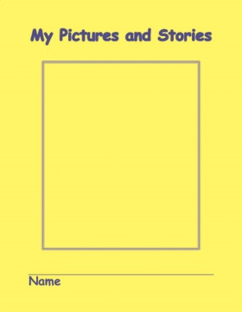

Supporting Pre-K & K Student

Work In My Pictures and Stories

*Getting Started*

* The journal is a supported teaching tool in Pre-K designed to be used *with* the teacher individually or in small groups, not independently.
* Designed for Pre-K students going to Kindergarten next year.
* Picture development (fine motor & visual discrimination) and oral language are the primary focus.
* Student orally tells the story before beginning any writing.
* Story needs to sound like a story. Point to elements on the narrative card during the oral pre-tell process.
* Teacher helps develop oral language and provides oral support to the story through questioning or adding sentences/words.

*Right Hand Side*

* Writing tools should be crayons that “drag”, rather than markers that “slip”. Small golf pencils work well for labeling and writing parts. Color for the picture in Pre-K.
* Teacher consistently changes child’s hand to a three-point grip on writing tools and/or supplies commercial pencil grip.
* The first focus is on creating “me” through the use of basic, well formed shapes-Circles, squares, rectangles, triangles.
* Bodies should be full shapes (ovals, circles, triangles), not stick figures.
* Student is encouraged to add details to themselves (me) that helps them identify themselves in the picture later.
* After the student draws the picture and retells the oral story, teacher has child add any missing details to include a critical part(s) of the story or add needed color to emphasize a part (i.e. red lips to highlight an emotion or blood on a boo-boo, etc.)
* As the child progresses and benchmarks indicate, teachers have students add more complex settings or significant event details such as lines that show movement or action, additions of a speech bubbles with words or random letters.
* The teacher may also add a critical detail using hand-over-hand or simply drawing them into the student’s picture.
* If student is capable, they label “me, mom, dad”- sight words copied from the yellow card. Otherwise teacher labels one or two words, while pointing to these on the narrative story card.
* The teacher writes one sentence of the most compelling part of the story below the line. *Teacher doesn’t write word-for-word dictation*.
* As students become more proficient in writing some letters, or no later than the 4th quarter of Pre-K, students are instructed to write letters (random letter strings or phonetically) below the line.

*Left Hand Side*

* Teacher enters the date and number of the entry. When doing an assessment entry, mark A1, A2 etc.
* Initially, and periodically the teacher scores the level of the student work in an *assessment with no teacher help* and indicates that score for current level of student work and oral language. Use the *Early Writing Assessment* for this. The score is carried forward to each entry page until the next assessment is completed and the new score updated.
* Teachers can demonstrate how to draw shapes, elements, features, actions, letters or words for the student to practice. Hand-over-hand can also be practiced here first and then on the student page.
* Teacher notes any support they gave to the student- i.e. things the student added, labeled, changed at teacher request; or things the teacher added or did, such as hand-over-hand or adding color, speech bubbles, labels, etc.
* Teacher indicates the next steps to work on in the next teaching session or during the next modeled writing.